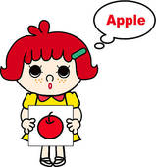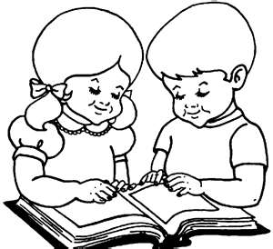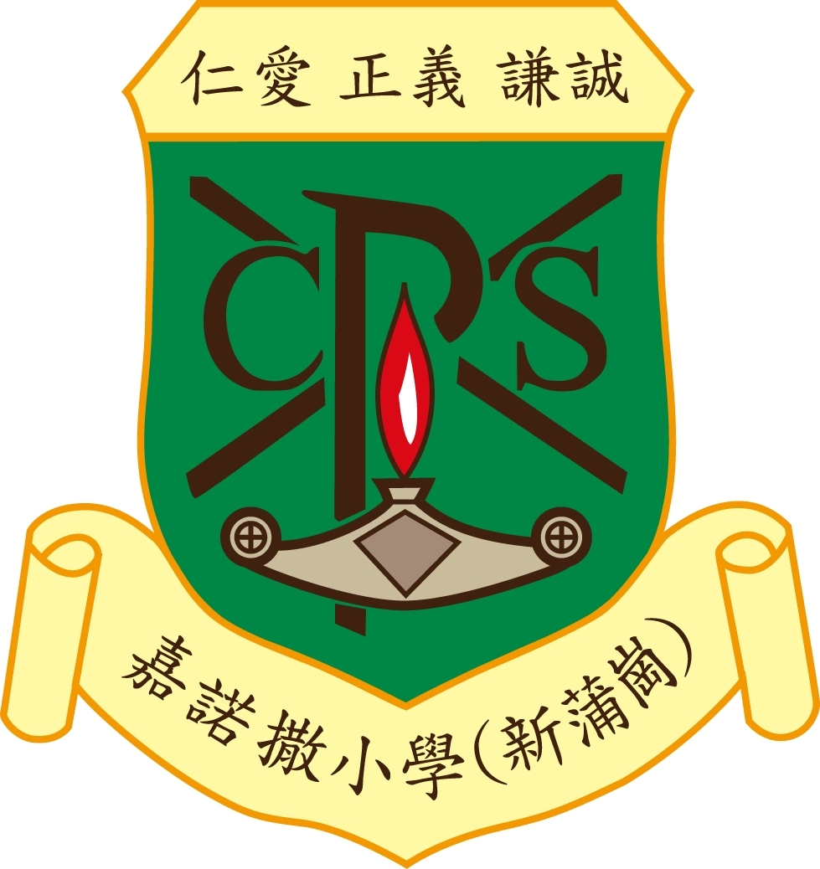

Name:_________________( ) Class :_____

Word Bank
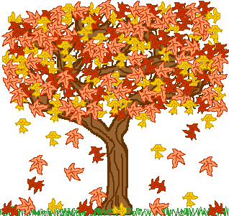1.Autumn | 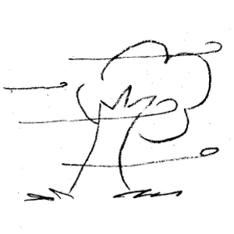2.windy | 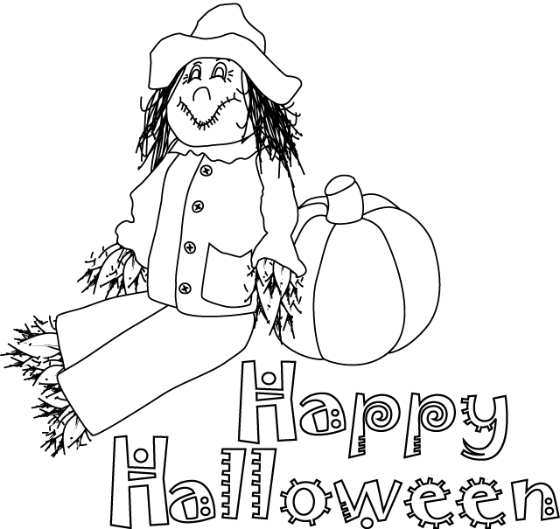3. Halloween | 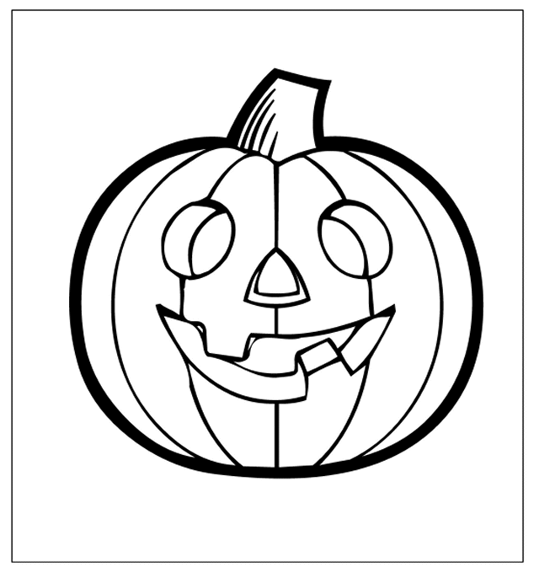4. pumpkin
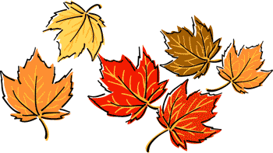5.leaves | 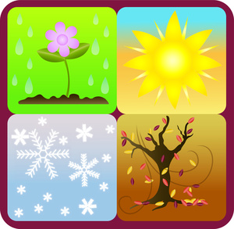6. season | 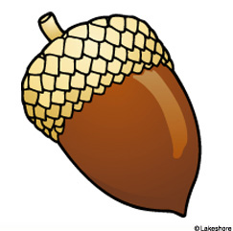7. acorn | 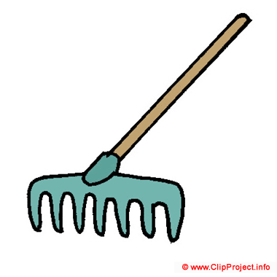8. rake
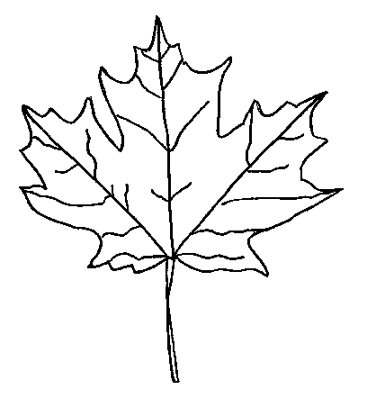9.maple lea f | 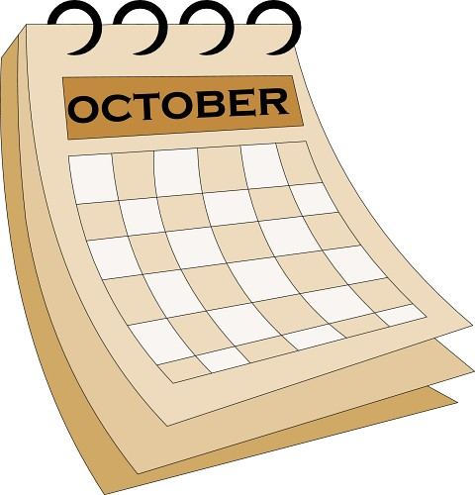10. October | 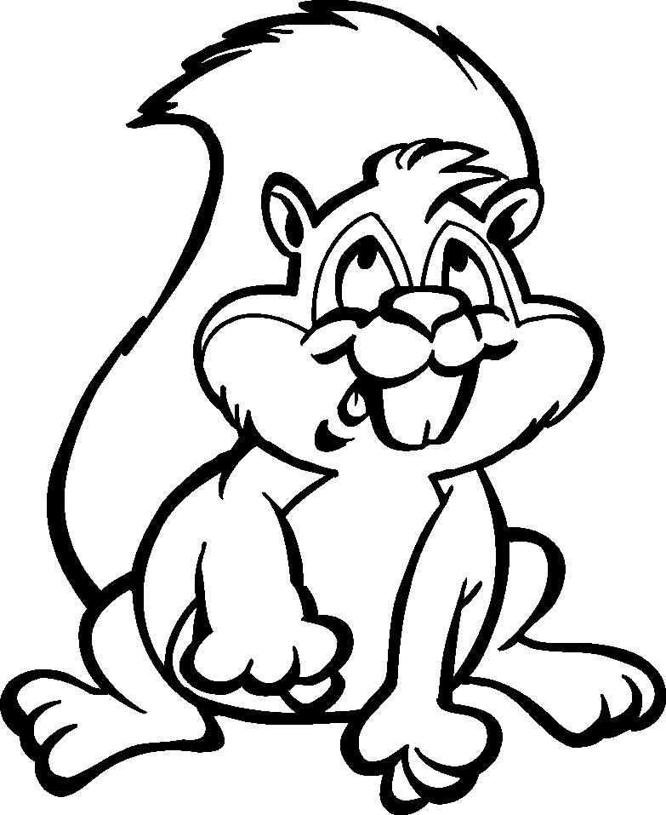 11.squirrel | 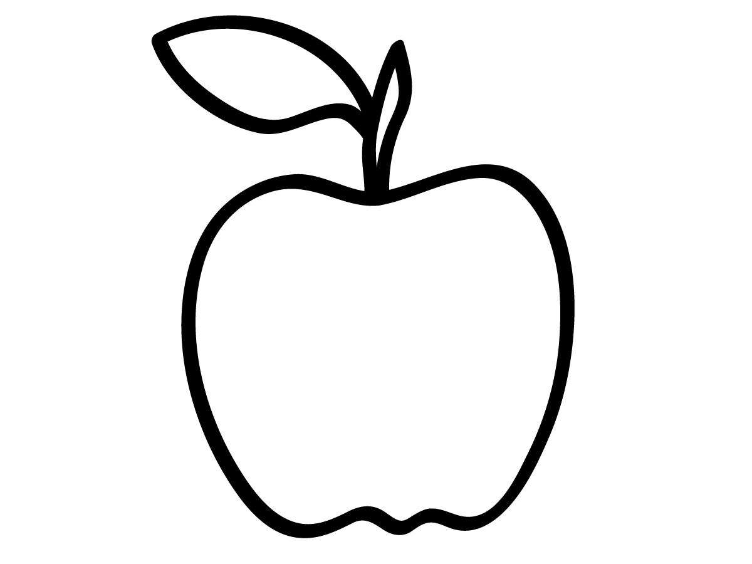12. apple

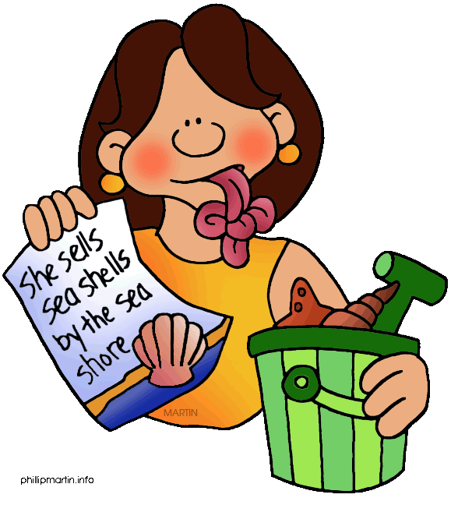tongue twisters

- I thought, I thought of thanking you on Thanksgiving Day.
- Can you can a can as a canner can can a can?
- I scream, you scream, we all scream on Halloween!
- Squeaky squirrel’s squeaky squeak!
- 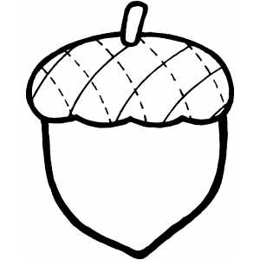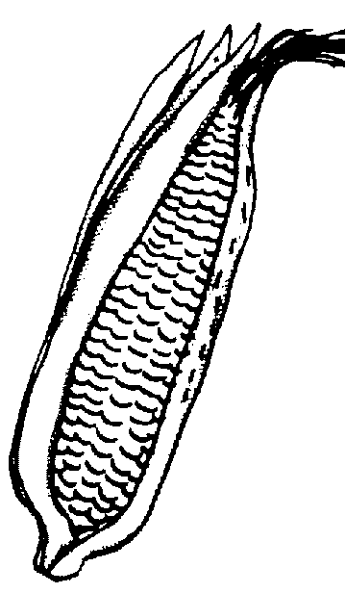A corn is a corn but an acorn is not a corn
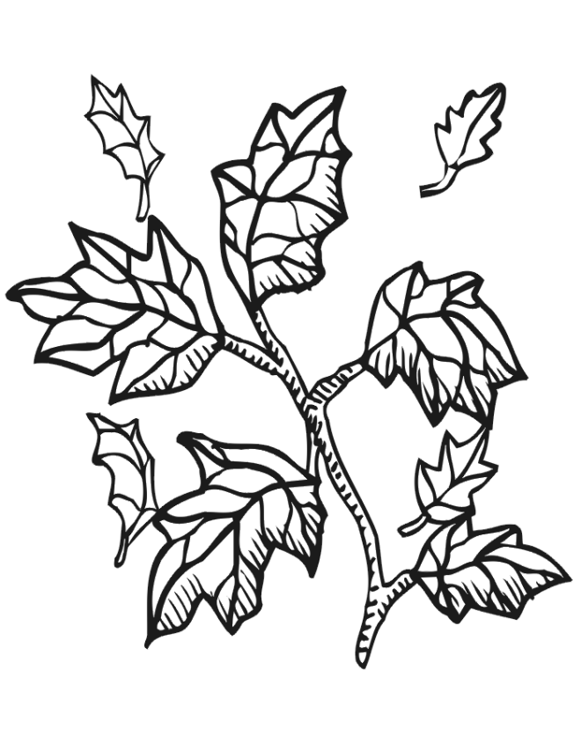
WORD FIND
How many words can you make out of : A U T U M N L E A V E S
1. | 2. | 3. | 4. | 5.
6. | 7. | 8. | 9. | 10.
11. | 12. | 13. | 14. | 15.
16. | 17. | 18. | 19. | 20.

 | Clues on the next page
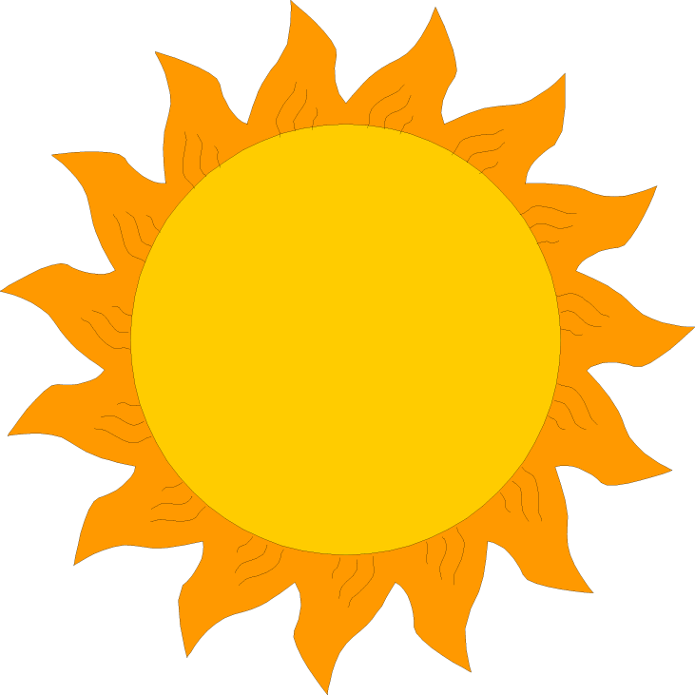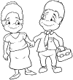CLUES:
An Uncle’s wife Gives us light in the day
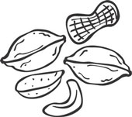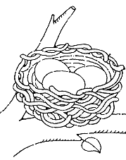
A bird’s house A squirrel’s snack
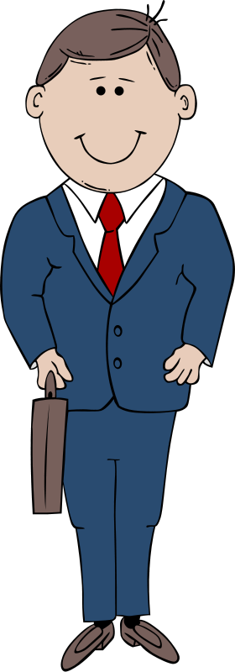
A part of a plant Opposite of woman
An insect To take things without asking
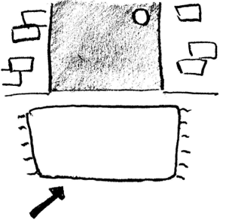Its water is salty The fat cat sat on a _______
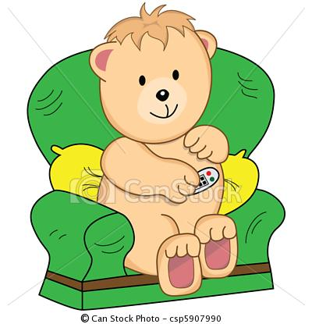
More than one man Past tense of sit
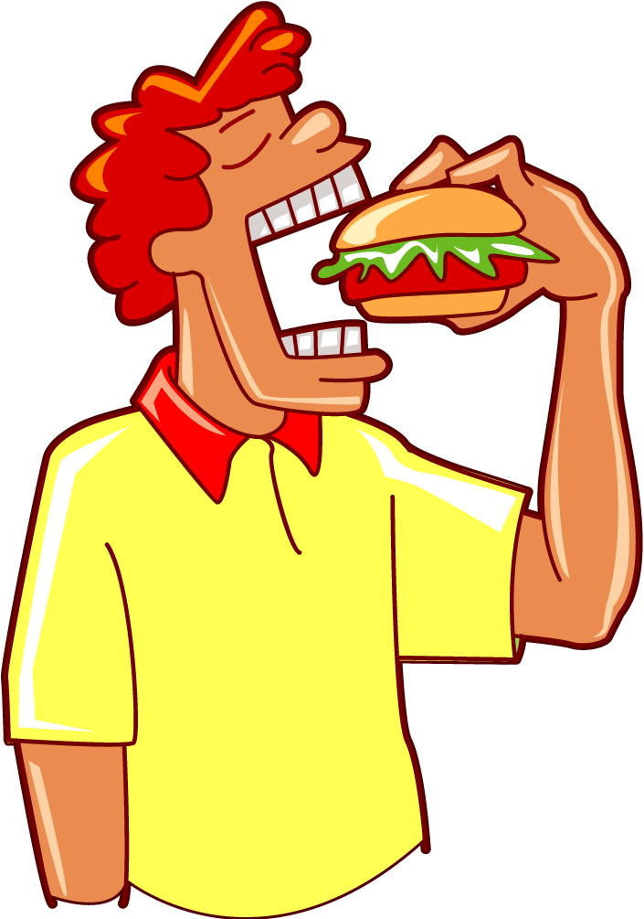
You cook a _______ What you do with food?

lehowaeln
esosan
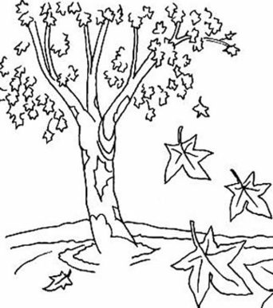  Unscramble the words and write on the next page: | btoreoc  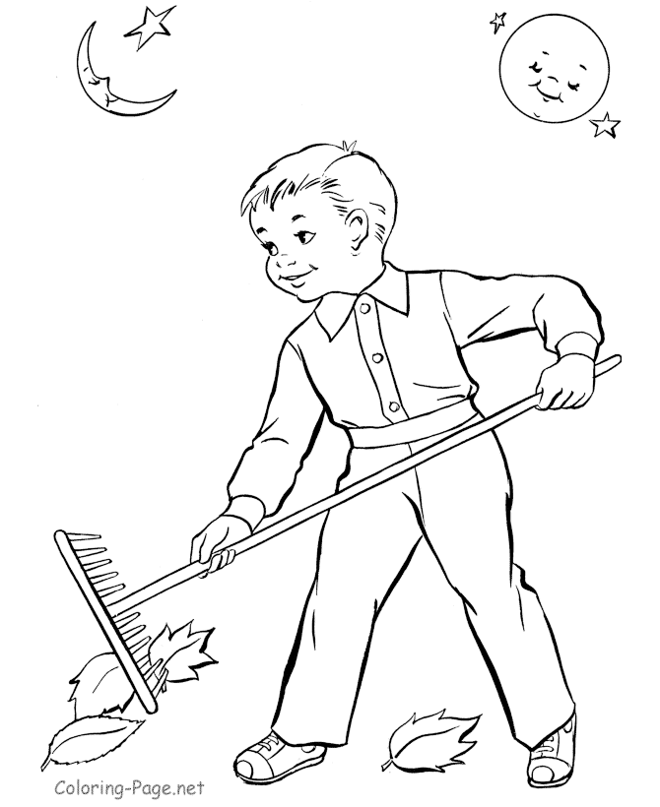  yinwd
 | selave

naumtu

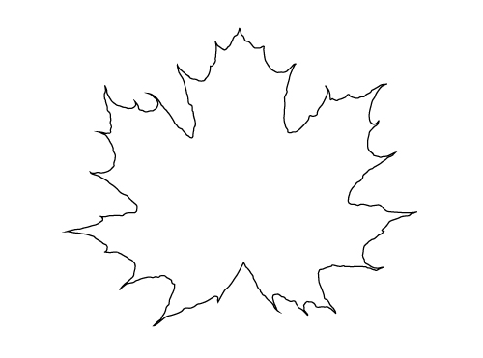

2.________
1.________
3.________

6._________
5.________
4.________

The Autumn Rhymes
Listen to the teacher and write the rhyming words:

1._______________ 2._______________ 3._______________
4._______________ 5._______________ 6._______________
7._______________ 8._______________
pumpkin | red | yellow | brown
corn | farm | Halloween | leaf

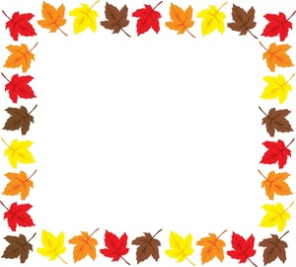Chant t he chant
Autumn is here!
Let’s sing a song,
red, yellow and brown.
The leaves are falling,
all over Hong Kong.
Collect all six stamps to get a treat!!

Autumn rhyme | Chant the chant
word find | tongue twister
unscramble the word | spell the word

- Go to the teacher
- See the nuts jar
- Guess how many nuts are there!

Answer:

Teacher Cues: (Not to be printed in the booklet) The NET can pass it out to the English teachers and ask them to give these riddles to the classes. Alternatively, the NET can announce them through the PA system.
10th October | - The color of leaves that rhymes with hello?  - What vegetable is yellow and rhymes with born?  - What falls to the ground during autumn and rhymes with reef?
17th October | - The color of leaves that rhymes with bed?  - Where is food grown that rhymes with arm?  - What’s a big orange vegetable that rhymes with skin?
24th October | - The color of leaves that rhymes with down?  - What autumn holiday rhymes with teen?

